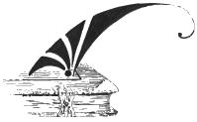 | Mennonite Historical Society of Alberta  210 – 2946 32 Street NE  Calgary, AB T1Y 6J7  (403)250-1121

Application form

Name

Address

Phone number

Email

Date of application ____________________________________________________

Membership type

Annual - $30.00

Lifetime - $500.00

Donations

Any donations made to MHSA in excess of the membership amount will be recognized with a tax deductible receipt.

I'm enclosing an additional $___________ as a donation to MHSA.

Payment

Please mail this form and an enclosed cheque to the address at the top of this page.

