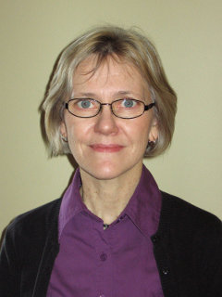
Mennonite Historical Society of Alberta
Fall Meeting
On Saturday Nov.21, 2015
Beginning at 1:30 pm
At Trinity Mennonite Church Range Road 12, De Winton,
Cost 20.00

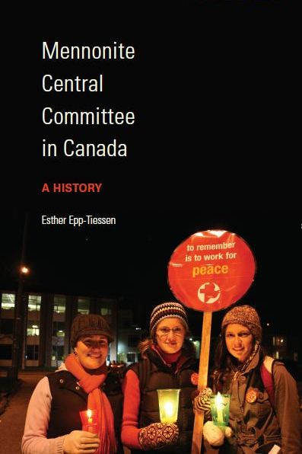
You are invited to come hear Esther speak on the book she has written Mennonite Central Committee in Canada from the beginning in 1920 to present.
Faspa will be served.

